**COLONIAL NEWS**

Health Committee Newsletter November 2024

Welcome to the Albert Gallatin School District Health Committee’s monthly newsletter. Each month this publication will provide our district with health and fitness information. Our goal is for our students, families, and staff to use this information to make healthy decisions and to live a healthy active lifestyle.

### Wall Push-Ups

* Stand with your feet a few feet away from a wall. Lean forward and place your hands on the wall at about chest height, arms and legs straight. (It’s like a raised, regular push-up, just against a wall.) You should feel some of your weight supported through your arms.
* Slowly bend your elbows and lower your chest toward the wall. Stop when your chest and head get close to the wall.
* Focus on keeping your body aligned as you pause in this position. (Don’t let your hips dip toward the wall or pop up.)
* Push through your hands and straighten your arms, returning to the starting position.
* As you do each rep, you might feel your arm, shoulder, and chest muscles working.

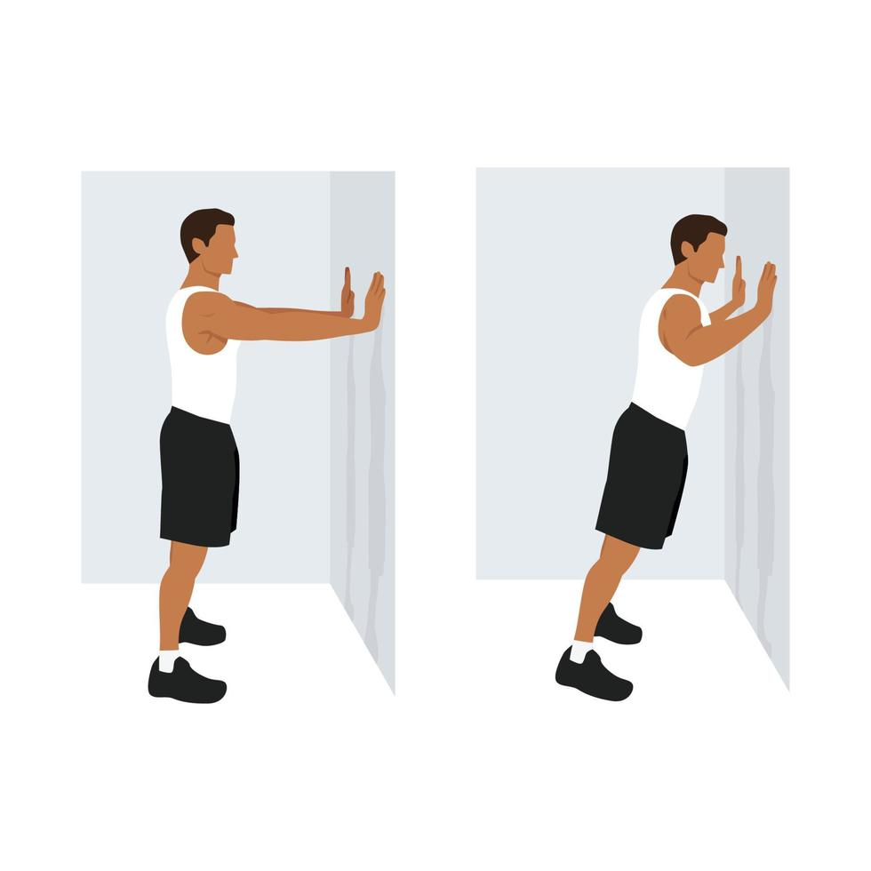

Before starting any exercise talk with your doctor to make sure they are safe for you based on your [fitness level](https://www.verywellfit.com/home-fitness-tests-3120282) and health conditions.

Source: hingehealth.com

|  |
| --- |
| **National Diabetes Awareness Month** |
| In the US, diabetes is so common that nearly 1 out of 2 adults has diabetes or prediabetes, when you’re at risk for Type 2 diabetes. That means that if you’re standing next to someone in line at the grocery store, chances are that either they’re on their way to diabetes (or maybe even already there) — or you are. And prediabetes has no symptoms, so most people are never even aware they have it.  Now that you know the scary stats, here’s some good news: it’s what you do every day that can help prevent Type 2 diabetes and prediabetes. These 4 tips can have a major impact:   1. **Eat right.** Limit or avoid alcohol, sugar, and refined carbs. Choose fresh, nutritious foods and make an effort to maintain a healthy weight. 2. **Exercise.** At least 30 minutes a day, 5 days a week. It keeps you strong, lowers inflammation, and helps you manage your weight. 3. **Get your sleep.** Try to go to bed and wake up at the same time every day, and prioritize 7 hours of sleep a night. 4. **Manage stress.** Some stress is normal, but too much can make you sick. Don’t turn to drugs, alcohol, or tobacco as ways to cope. Instead, find more productive strategies, like mindfulness or a fun hobby.   These healthy habits alone will do more to prevent diabetes — or help you manage it, along with the rest of your treatment plan — than just about anything else. |

(Adapted from Source: ACSHIC Wellness News

For more information regarding diabetes, visit the American Diabetes Association website at diabetes.org

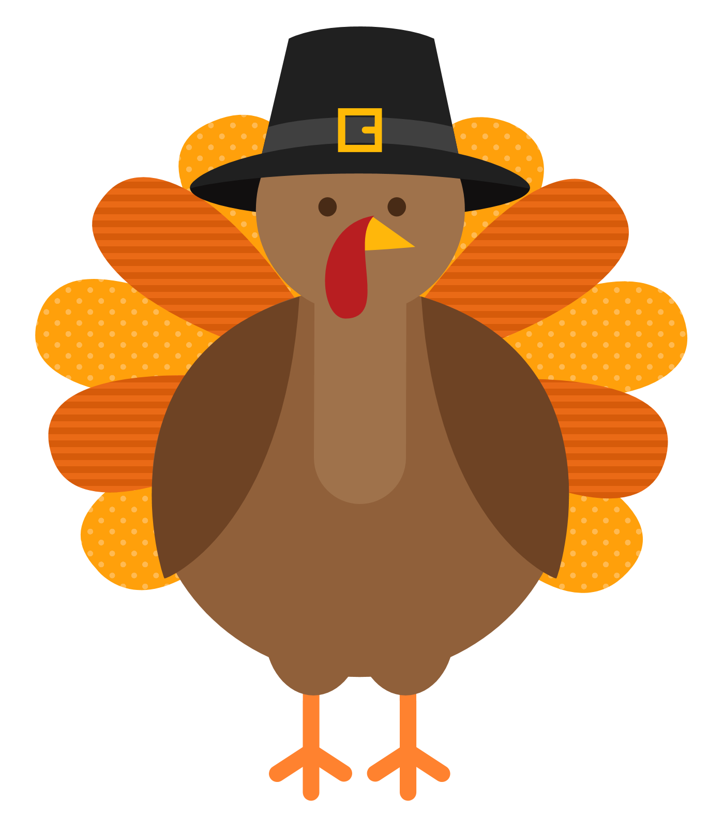

Happy Thanksgiving!

Prepared by Lisa Sumey, Central Office Secretary

**Recipe of the Month**

# Turkey-Cranberry Wrap

# This wrap is quick-and-easy to prepare and is the

# perfect lunch solution for all of those Thanksgiving leftovers.

#### Ingredients

* 2 ½ tablespoons whipped reduced-fat cream cheese spread
* 1 Light Flatbread
* 1 cup torn romaine lettuce
* 3 ounces sliced cooked turkey or chicken breast meat
* 2 tablespoons reduced-sugar or light cranberry sauce

#### Instructions

1. Spread cream cheese over one side of flatbread.
2. Top with romaine, turkey and cranberry sauce.
3. Roll up flatbread to enclose filling.

Adapted by Source: eatingwell.com

   
  
  
  
   
  
 

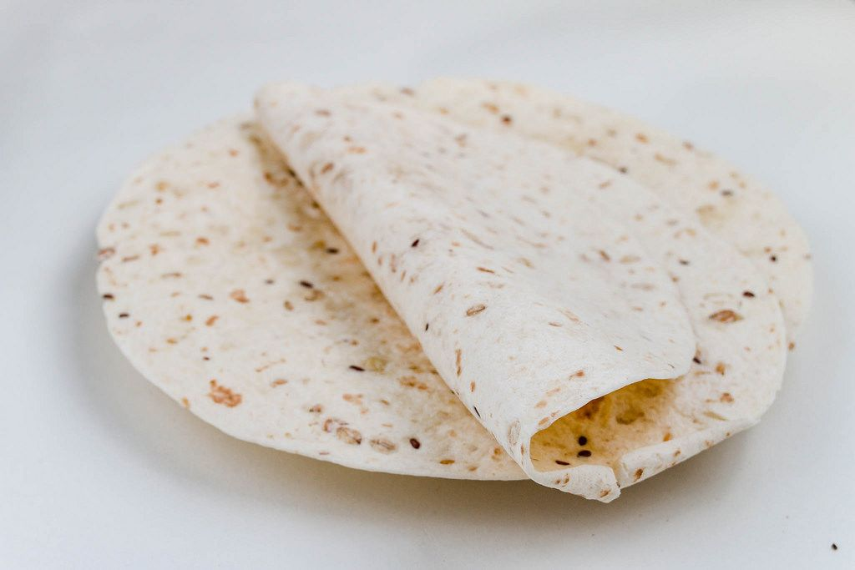

# Healthy Tips for the Holidays

The holiday season is upon us. As you celebrate and connect with the people you care about keep these tips in mind for a healthy holiday.

# Don’t skip meals to save up for a feast.

* Invited to a party? Offer to bring a healthy dish along.
* Start with vegetables to take the edge off your appetite.
* Have a small plate of the foods you like best and then move away from the table.
* Eat slowly. It takes at least 20 minutes for your brain to realize you’re full.
* If you have a sweet treat, cut back on other carbs (like potatoes and bread) during the meal.
* Keep moving. Break physical activity up into smaller chunks so it’s easier to schedule, like walking 10 minutes several times a day.
* Schedule some “me” time – take a nap, walk the dog, or take a hot bath to get your energy back for the next celebration.

(Adapted from Source: CDC.gov)

For more information visit: CDC.gov